Experiment No: 02
Experiment Name:
i. Write an assembly language program to print a string using EMU8086.
ii. Write an assembly language program to add two numbers using EMU8086.
iii. Write an assembly language program to subtract two numbers using EMU8086.

Theory: EMU8086 assembly handles string output and single-digit arithmetic using DOS interrupts. To print a string, load 09H into AH, point DX to the '$'-terminated string, and call INT 21H. For addition, read two ASCII digits into BL and BH, add them, subtract 48, and save the result in BL. For subtraction, read two ASCII digits into BL and BH, subtract BH from BL, add 48, and save the result in BL. Set AH to 2 and output ASCII 10 and 13 to create a new line. Move the result from BL to DL, set AH to 2, and call INT 21H to display it. Load 4CH into AH and call INT 21H to exit and return control to DOS.

Code & Output:
i) Code for printing a string:
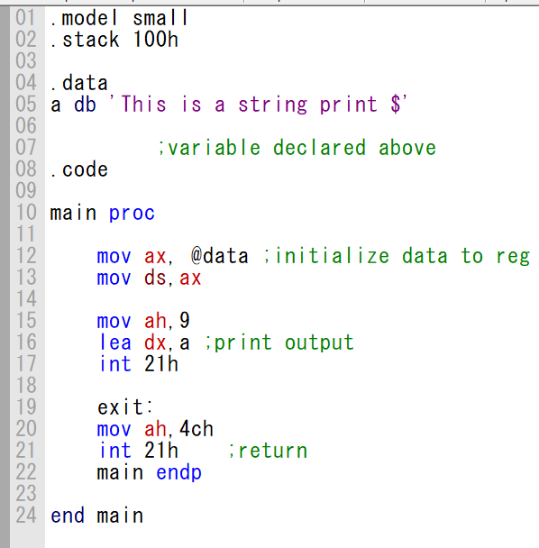

B8 20 07 8E D8 B4 09 BA 00 00 CD 21 FF FF CF B4 4C CD 21 FF FF
Machine Code:

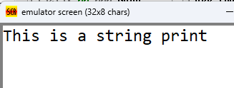
Output:
Output

ii) Code for add two numbers and display output on a new line:
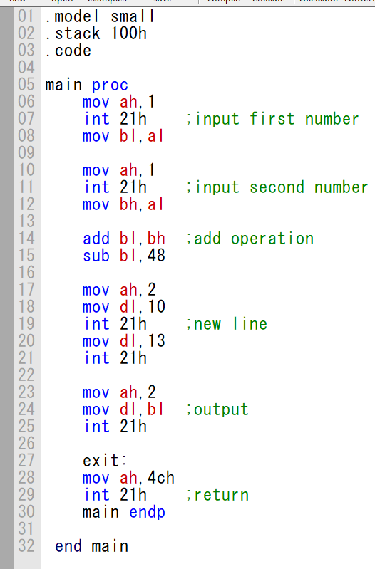

B4 01 CD 21 FF FF CF 8A D8 B4 01 CD 21 FF FF CF 8A F8 02 DF 80 EB 30 B4 02 B2 0A CD 21 FF FF CF B2 0D CD 21 FF FF CF B4 02 8A D3 CD 21 FF FF CF B4 4C CD 21 FF FF

Machine Code:

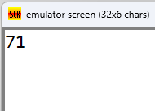
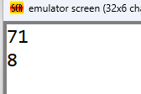
Output:
Input
Output

iii) Code for subtract two numbers and display output on a new line:
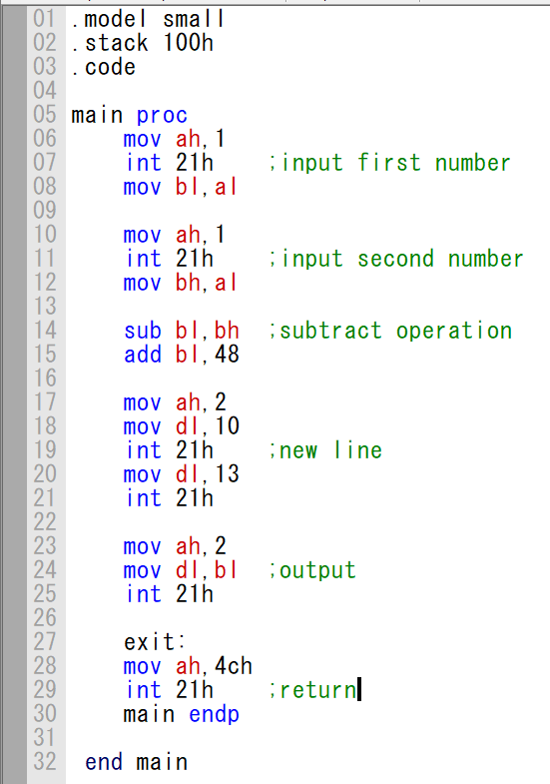

B4 01 CD 21 FF FF CF 8A D8 B4 01 CD 21 FF FF CF 8A F8 2A DF 80 C3 30 B4 02 B2 0A CD 21 FF FF CF B2 0D CD 21 FF FF CF B4 02 8A D3 CD 21 FF FF CF B4 4C CD 21 FF FF

Machine Code:

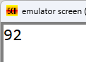
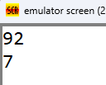
Output:
Input
Output

Conclusion:
The program was executed successfully in the EMU8086 environment, and no errors were found. We successfully learned any string printing using EMU8086. We also learned two basic arithmetic operation of add an subtract of single digit in assembly language.

